Assignment (N+) Network topology
Task-1:
- Star Topology
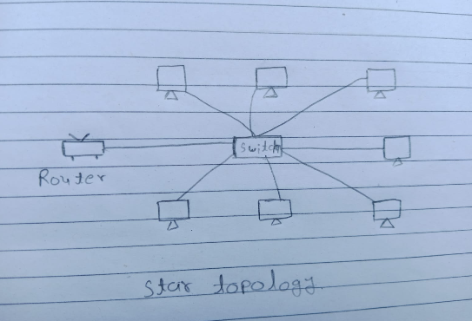
To draw this, put one box in the center and label it “Central Switch or Hub.” Now draw 5 or 6 small circles around it, like the rays of a sun. Label each circle “Computer 1,” “Computer 2,” and so on. Draw a straight line from each computer to the central box. No computer should be joined to another computer. Every line goes only to the center. A real-world example is Flipkart. Think of Flipkart’s main server as the center, and all the users, sellers, and delivery apps as the circles around it. All of them talk to the main server, so Flipkart can easily control orders, payments, and data in one place.
- Bus Topology:
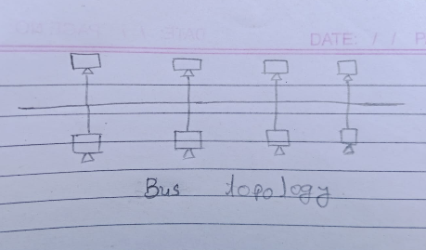
To draw this, first draw one long straight horizontal line in the middle of your page and label it “Main Cable” or “Bus.” At both ends of the line, draw a small block and label it “Terminator.” Now draw 4 or 5 short lines going up and down from the main cable. At the end of each short line, draw a small box and label it “Computer 1,” “Computer 2,” and so on. All the computers share the same main line. A real-world example is a small old-style office or school computer lab network, where a few computers share one cable to use a common printer and files. It works because it is cheap and needs very little cable, so it suits a small place with a low budget.

- Mesh Topology
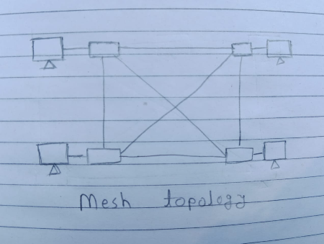
To draw this, draw 5 circles spread out on your page, like the corners of a pentagon. Label them “Device A,” “Device B,” “Device C,” and so on. Now join every circle to every other circle with straight lines. You will see many crossing lines inside the shape, and that is correct. In a full mesh, each device has its own direct link to all the others. A real-world example is IPL streaming on a platform like JioCinema. The internet servers that carry the match video are joined to each other in a mesh-like way. If one link breaks or becomes slow, the video can take another path, so viewers do not see the match stop.

Task-2:
- Star Topology:
Pros | Cons
Easy to add new devices. | If the center hub breaks, the whole network stops.
The central hub makes it easy to find and fix problems. | Needs more cable than a bus network.
One broken cable only affects one device, not all of them. | Buying the central switch adds extra cost.
Very simple to set up and manage. | Speed depends totally on the center hub.

The best use case for a Star topology is a home Wi-Fi network or a modern office setup. An app example is Paytm, where your phone connects directly to a central banking server to process a payment rather than talking to other users' phones.
- Ring Topology
Pros | Cons
Data travels one way, so it doesn't crash into other data. | One broken computer breaks the whole circle.
Handles heavy traffic steadily. | Adding new devices means shutting down the network.
No need to buy a central server. | Data is slow because it passes through many stops.
Every device gets an equal turn to send data. | Very hard to find and fix problems.

The best use case for a Ring topology is automated factory machines or older campus networks. An app example is Zomato passing a delivery driver's GPS location to the server and back to your screen in a continuous loop.

- Mesh Topology
Pros | Cons
Extremely reliable because data finds another way if a path breaks. | It is the most expensive topology to build.
Highly secure. | Needs a huge amount of cabling.
Handles massive amounts of traffic at once. | Very complicated to set up and manage.
Easy to grow without turning the network off. | Takes up lots of physical space.

The best use case for a Mesh topology is huge data centers, military communications, and the Internet. An app example is Instagram, which uses a massive network of backend servers to keep your feed refreshing even if several individual servers crash.

Task-3:
I would choose a star topology for the game, where all players connect to a central game server. This is good for speed because every player’s move goes to one place, and the server quickly sends it to everyone else in the match. For reliability, I would keep a backup server ready, so if the main one fails, the game does not stop. It is also cheap, because adding a new player only needs one new connection, not links to every other player like in a mesh. The only small problem is that too many players can slow the server, so I would add more servers in different cities to keep the game smooth.

Task-4:
I recommend a Star topology where all 8 computers connect directly to one central switch in the middle.
This is the best choice because it is cheap to set up, and you can easily add more computers later without shutting down the whole warehouse.
Also, if one computer's cable breaks, the rest of the network keeps working perfectly, making it very easy to find and fix the problem.

